

Faculty of Science and Information Technology  
Daffodil International University  
**Final Year Project/Thesis – Students Guide**

*Please Read this guide carefully*

*It is your responsibility to be familiar with its content*

*It is your responsibility to maintain progress and contact with your supervisor.*

*Meet regularly and complete a Log Sheet while meeting with your advisor.*

**1.0 Introduction**

Daffodil International University continuously fosters quality in ICT education and the university policy stipulate that a satisfactory level of performance in the Project must be achieved in order to gain the final award. Unsatisfactory performance in the Project cannot be compensated by performance in other courses.

The success of students project will depend to a large extent on the student’s ability to take the initiative and work independently or in a team through collaborative group work with optimal supervision. The amount of work required for their project is such that they cannot complete it satisfactorily unless their start straight away and continue to work steadily throughout the time allotted to them which is two semester long.

**2.0 Choosing Thesis/Project**

Undergraduate student projects will normally be related to the job market or choice of career and the project scope will be decided in consultation with project supervisor and/or the job consulting body. The student’s Supervisor will verify that the project is appropriate to the student’s choice of skill needed for the purpose specified.

Graduate Student thesis/projects will normally be work-related and this will be specified by the student in co-operation with the employer and/or in discussion with the Supervisor. The student’s Supervisor will also verify that the scope of the work is appropriate to the student’s targeted level.

Students are strongly encouraged to write their own thesis/project specifications and to discuss them with the Head of the Department (HoD) with a view to finding a Supervisor. HoD will make every effort to accommodate student-generated thesis/projects. Before accepting the proposal, the Supervisor approached will make a judgement on whether (1) the proposal is appropriate to the required objectives, (2) identify any incurred costs of the proposal, and (3) the required facilities.

If student do not have an idea for a thesis/project or if he cannot find a supervisor for the project they proposed, then they will need to choose a thesis/project from the Specifications List provided by the Department in every semester. They are required to contact the Supervisors for the thesis/projects of their choice for additional information. When they have made a final choice, then they will see the Supervisor to finalize the project.

**3.0 Project Planning and Management**

The project planning and management plays a vital role in the successful accomplishment of the proposed work as well as assessments. This assessment includes components such as logbook (See Appendix A), draft copy of the project report, user manual, if any, and personal qualities of students. The student must ensure that a good record of the work done by him/her throughout the semesters which is maintained in a logbook. A logbook is particularly useful for continuing projects. The purpose of a draft copy of the project report is for the supervisor to suggest changes/modifications, if any, to poorly structured reports, key concepts, ideas, results, etc., indicated in the report, and also to point out any violations like plagiarism.

The student must be assigned necessary tasks to exercise care and responsibility in producing a good report. The project advisor assesses personal qualities like ability, independence, responsibility, efficiency and effectiveness as they are thought to contribute to the successful completion of the project.

The initial project plan should comprise of the following key points:

1. Define your concept or idea.

2. Define your objectives clearly.

3. Break the project down into tasks.

4. Show when you will do what and how.

5. Show what resources will be used.

6. Show when activities are expected be achieved.

7. Indicate how you will monitor progress.

In the entire project management plan, time management is essential. The students must pay attention to the credible use of time that is required to implement a project. Use template shown in Appendix-B to submit their thesis/project proposal plan.

**3.1 Interim Assessment Report**

During the course of the thesis/project, it is compulsory for each student/team to submit a short interim report at the end of the first/second phase of the thesis/project before the final report and presentation. The report will highlight the progress made by the students/team towards meeting the objectives laid out in his/her thesis/project plan/strategy and will be limited to a maximum of 4-5 A4 pages. This interim assessment will be carried out by the advisor/supervisor only. The interim report must be submitted to the department duly signed by the supervisor as shown in Appendix-C.

**4.0 Submission and Presentation**

Student will need to submit (1) a final Project Report witha supporting CD/DVD/USB attached. They must be submitted by thedeadline dates declared by the department. They will also need to bring a presentationCD/DVD/USB along with the required demonstration during the final presentation and interview.

**5.0 Report Writing**

The department requires two copies of the project report. A third copy should be retained by the student himself for personal use and for reference at your presentation and interview. The report must be written in English.

Once the report is ready, students are advised to go through it once again and correct out all redundant and irrelevant information and material. If you are able to communicate the information clearly in fewer words, this will likely add to the clarity and appeal of your report and could earn you extra points.

The page size must be A4 with a margin of 32 mm (1.3 inch) on the binding edge (left) and 20 mm (0.787 inch) elsewhere (right). The report must be prepared on computer with text in Times New Roman font size 12 or equivalent. It is your responsibility to arrangements for the report to be typed. Single sided reproduction with single line spacing should be used.

The report must be permanently bound in soft covers. Spiral binding or thermal binding is acceptable. Large additional papers or other material deemed to be essential for satisfactory presentation of your work may exceptionally be submitted in a separate folder but consult your Supervisor before doing so.

**5.1 Supporting CD/DVD/USB**

A CD/DVD/USB should be firmly attached to the inside back cover of the report to support presentation/source code etc. This should also contain a copy of the report in word format. In addition the CD/DVD/USB should also illustrate those aspects of the outcome of your work which cannot be adequately illustrated in the report.

**5.2 Plagiarism**

Plagiarism is an offense and fabrication of results are not allowed. These are serious offences of deception which will be the breaches of assessment regulations under the university policy. Quotation and facts of other’s work should be addressed with proper reference. This is likely to lead to the cancellation of the thesis/project. Students are requested to check the report using the software tool *Viper (http://www.scanmyessay.com/)* for detection of plagiarism. The viper reported plagiarism must be less than 10% for the report to be accepatble.

**6.0 Structure of Project Report**

The project report should be adhere to the standard and norms outlined in the following sub-sections. The detail template is shown in the Appendix – B.

**6.1 Front Cover and Title Page : Appendix D**

The title page of the thesis/project should include:

* The title of the work. This should indicate as accurately as possible the contents of the report
* The ID and name of the student/author
* The name of the supervisor
* The name of the faculty and university
* The award title, e.g. BSc/MSc in Computer Science and Engineering (an example)
* The date (month and year)

**6.2 Abstract**

The abstract of the report should summarize the aims and objectives of the work, the procedure followed, and the results obtained. It should not exceed one A4 page in length. It should be on a separate page and self-contained. That means that it should stand alone and make no reference to sections, figures, or references in the report.

**6.3 Acknowledgements**

Acknowledgement of the report should also be on a separate page and should acknowledge all significant sources of assistance, both for advice and for facilities, materials, funds and other means of support received during the work.

**6.4 Contents Page**

Content page should indicate the section headings and associated page numbers. Lists of tables and appendices should be included. The page numbering is essential and should be given in the middle of the bottom of the page. Chapters and sub-sections should be numbered with a decimal classification. Do not to subdivide a section more than twice, e.g., section number 3.4.2 is satisfactory; 3.4.2.1 is undesirable.

**6.5 Introduction**

The introduction serves to set the scene or scope of the intended goal. It identifies the overall theme of the work and will usually explain the needs that have led to the project proposal. It should provide sufficient background for the reader to fully appreciate the context of the work.

This will almost always require a review of previous work, on which the work is based, with appropriate references to the technical literature. Also, the aims and objectives of the work and the main conclusions reached should be stated in order that the reader may fully appreciate the logical sequence of events.

**6.6 Main Body of Report**

This will normally consist of several chapters each describing distinct parts of the work, such as analytical work, numerical work, experimental work, and presentation and discussion of results from which the conclusions and recommendations are subsequently derived.

All figures, graphs, charts, tables, drawings, photos, etc. must be numbered and have caption/titles and they must be referenced in the text. Also, it must be made clear in the text what purpose they serve. If they are not mentioned in the text, they are clearly not relevant to the work and they should be omitted from the report. Extensive amounts of analytical and mathematical work, unless original or essential to the development of the text, are usually better presented in appendices.

As a general rule, numerical tables should be avoided and their content instead be displayed in graphical form at an appropriate point in the main body of text. Where the use of tables is unavoidable, confine their use to summary tables of processed data and consideration should be given to include them in appendices.

**6.7 Discussion**

This is the section in which an overall appraisal of the results of the work will be presented. It is here that one will have the opportunity to demonstrate the understanding of the work and to give a critical account of what has been achieved. This is a very important section of the report in terms of the assessment of work.

**6.8 Conclusion**

The Conclusion is a short summary of the results of the work, no more than one page long. The Conclusion should follow naturally from the Discussion. It should give a concise statement of what has been achieved. Anticipated applications of techniques developed should be summarized very briefly. The Conclusion should be self-contained, i.e., it should not make reference to any sections, figures, or references in the report. The reader must be able to understand the Conclusion having read only the Abstract.

Make sure that one understand the difference between the Discussion and the Conclusion and these should not be mix them up.

**6.9 References**

All references to books, papers, and other publications must be fully and correctly quoted. There are several methods of quoting references. One is to state the name of the author and a serial number in the main text with the full details of the reference in the Reference section of the report, for example:

In the text:

*....The analysis of the algorithms has been extensively reviewed by Knuth [12]*

*and will ....*

In the References section:

*12. Donald Knuth, "Analysis of Algorithms", Bell Systems Technical Journal, Vol. 44, pp 75-92, April 1989.*

Another, more modern approach, is to give the author’s names and the year of publication in the main text with full details in alphabetical order, according to authors’ surnames, in the Reference

section, for example:

In the text:

*....The analysis of the algorithms has been extensively reviewed by Knuth (1989)*

*and will ....*

In the References section:

*Knuth, Donald (1989), "Analysis of Algorithms", Bell Systems Technical Journal, Vol. 44, pp 75-92.*

This latter system is often called the” Harvard System” and has advantages when adding further references over a period of time as when writing a project. This latter system is now the preferred system in academic circles and is the one that one should use. Any one of the system should be followed and mixed system should not be used.

**6.10 Bibliography**

This section is not always necessary but is used to indicate where further references have been used which are not directly referenced in the text. It may refer to general material that is useful for relevant additional reading. Make sure that one understand the difference between References and Bibliography and don't mix them up.

**6.11 Appendices**

The main body of the report should flow smoothly and logically and sustain the reader’s attention. Any material that interrupts this flow should be considered for inclusion in appendices. Detailed proofs, computer source code listings, glossaries of terms, equipment specifications, and data sheets are all usually best presented in appendices.

**6.12 Supporting CD/ DVD/USB**

A supporting CD/DVD/USB to the Report as described previous section should be attached while submitting the report.

**7.0 Presentation**

Student must prepare very well for the presentation. The following sub-sections highlight important preparation issues:

**7.1 Presentation CD**

Student need to prepare a CD with a PowerPoint presentation or similar for use at the Presentation and Interview. This is not the same as the supporting CD/DVD/USB which is submitted with the Project Report as described in the previous section.

**7.2 Preparation of Presentation**

One or two vital points may be chosen to make, e.g., the main conclusion from the report. Prepare a sequence of about five/six presentation slides: Include the name and project title, Abstract and Conclusion bullet points, graphs, drawings, photos, etc. which will enable a spectator with no prior knowledge of the work to understand (1) what is accomplished, (2) why one did it, and (3) what one achieved. Use key photos and/or simplified versions of key figures, graphs, etc. from the report. Avoid tables. Use graphs if possible.

Use a few short, punchy, one-line bullet points. Lengthy prose kills most readers’ interest. Do not copy written text from the report for use in the presentation. It looks unprofessional and indicates a lack of commitment. Once finished the presentation, then review it. Imagine oneself to be a spectator.

***It is strongly advised to discuss and prepare presentation in consultation with the Supervisor***

**7.3 Presentation**

Give a brief overview of the motivation and background for the work. Describe the new and different aspects of the work. Give a summary of the conclusions.

Be as natural and spontaneous in the delivery as possible. The audience is generally sympathetic and eager to hear what one has said. Talk around the bullet points in the presentation. Avoid reading from text. It sounds boring. If one forget something, it probably is not essential. And if the remainder of the presentation is clear, the audience will recognize a significant omission and will ask questions.

**The following documents shows a report sample**

**FINAL YEAR PROJECT AND INTERNSHIP REPORT TEMPLATE [Title]** [bold, font 12]

**by**

**NAME**

**ID: XXX-XX-XXXX**

**AND**

**NAME**

**ID: XXX-XX-XXXX**

This Report Presented in Partial Fulfillment of the Requirements for the Degree of Bachelor of Science in Computer Science and Engineering [Font-14]

Supervised By

**Name[Font-14, Bold]**

Designation[Font-14]

Department of CSE

Daffodil International University

Co-Supervised By

**Name[Font-14, Bold]**

Designation[Font-14]

Department of CSE

Daffodil International University



**DAFFODIL INTERNATIONAL UNIVERSITY** [font-14, capital letter, bold]

**Dhaka, Bangladesh**[font-14, bold]

**June 2014**

**APPROVAL**[capital letter, Bold, Font-14, Alignment-middle]

This Project titled **“Title**”, submitted by *Name1* and *Name2* to the Department of Computer Science and Engineering, Daffodil International University, has been accepted as satisfactory for the partial fulfillment of the requirements for the degree of B.Sc. in Computer Science and Engineering (BSc) and approved as to its style and contents. The presentation has been held on *date*.[**Font-12**]

**Board of Examiners**

**(Name)** [**Font-12, Bold**] **Chairman**

**Designation**

Department of CSE [**Font-12**]

Faculty of Science & Information Technology

Daffodil International University

**(Name) Internal Examiner**

**Designation**

Department of CSE

Faculty of Science & Information Technology

Daffodil International University

**(Name) External Examiner**

**Designation**

Department of -------

Jahangirnagar University

**Declaration**[capital letter, Bold, Font-14, Alignment-middle]

We hereby declare that, this project has been done by us under the supervision of **Name, Designation, Department of CSE** Daffodil International University. We also declare that neither this project nor any part of this project has been submitted elsewhere for award of any degree or diploma. [**Font-12**]

**Supervised by:**

**Name**

Designation

Department of CSE

Daffodil International University

**Submitted by:**

**(Name1)**

ID: -19-

Department of CSE

Daffodil International University

**(Name2)**

ID: -19-

Department of CSE

Daffodil International University

**ACKNOWLEDGEMENT  
[**capital letter, Bold, Font-16, Alignment-middle**]**

First we express our heartiest thanks and gratefulness to almighty God for His divine blessing makes us possible to complete the final year project/internship successfully.

We really grateful and wish our profound our indebtedness to **Supervisor Name**, **Designation**, Department of CSE Daffodil International University, Dhaka. Deep Knowledge & keen interest of our supervisor in the field of “*Field name*” to carry out this project. His endless patience ,scholarly guidance ,continual encouragement , constant and energetic supervision, constructive criticism , valuable advice ,reading many inferior draft and correcting them at all stage have made it possible to complete this project.

We would like to express our heartiest gratitude to -----, -----, andHead**,** Department of CSE, for his kind help to finish our project and also to other faculty member and the staff of CSE department of Daffodil International University.

We would like to thank our entire course mate in Daffodil International University, who took part in this discuss while completing the course work.

Finally, we must acknowledge with due respect the constant support and patients of our parents. [**Font-12**]

**Abstract[**capital letter, Bold, Font-14, Alignment-middle**]**

[This is sample abstract] This report is intended as a guide for teachers and engineering students when conducting research is part of course-work requirements. Discussion includes a description of a literature search, the purpose of a literature review finding sources (especially for engineering) and a general strategy to help conduct an efficient and productive literature search. Using tools such as this report, students can become more pro-active about their research projects. Teachers can use this report, among other tools, to begin dialog with their students about expectations for research assignments. Two key steps in a literature search are: (i) finding sources; and (ii) synthesizing information. Each of these is addressed in two of the major sections in this report, as well as how the literature search relates to the entire research process. Then pertinent information is repeated in the summary section for convenience. An annotated reference list is included for ease in finding other useful guidance. [**Font-12**]

**Abstract should be between 150-200 words and not more than two paragraphs.**

**TABLE OF CONTENTS [**capital letter, Bold, Font-14, Alignment-middle**]**

|  |  |
| --- | --- |
| **CONTENS[**Font-14, bold**]** | **PAGE** |
| Board of examiners**[**Font-12**]** | i |
| Declaration | ii |
| Acknowledgements | iii |
| Abstract | iv |
| **CHAPTER**[**Font-14, Bold**] |  |
| **CHAPTER 1: CHAPTER NAME [**Font-14, **Bold]** | **1-6** |
| 1.1 Infrastructure Mode**[**Font-12**]** | 1 |
| 1.2 | 2 |
| **APPENDIX** | **50-55** |
|  |  |
| **REFERENCES** | **56-57** |

**LIST OF FIGURES** [**Font-14, Bold**]

|  |  |
| --- | --- |
| **FIGURES**[**Font-12,Bold**] | **PAGE NO** |
| Figure 1: Cabling and Computer Hardware[**Font-12**] | 4 |
| Figure 2.1.1: numbering according to sub sections | 11 |

**Instructions for figures:**

a. Caption of every figure must insert at the bottom of the figure with center alignment.

b. Figure’s number and description must need to be mentioned in the main documents about what it actually illustrates and what it explains.

c. Figure’s number must be sequenced according to the section numbers and arranges with sub sections accordingly if needed.

d. All the figures must need proper citation if it used from other resources.

Sample:

1. The following figure 1 shows basic multicast service.

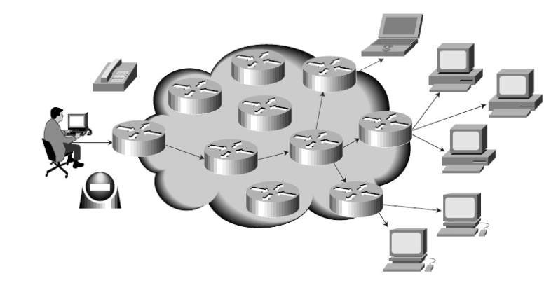

Figure 1: Basic multicast service

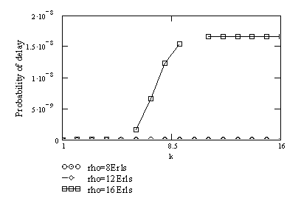

Figure 2.1.1: Probability of delay as a function of the fold number under different offered traffic (N=50, n=14, q= 5,

**Instructions for Table:**

1. Caption of every table must insert at the top of the table with center alignment.

2. Table’s number and description are must be mentioned in the main documents for what it actually shows and what it explains.

Table 1: The relationship between gaze targets and proxemics from case 1

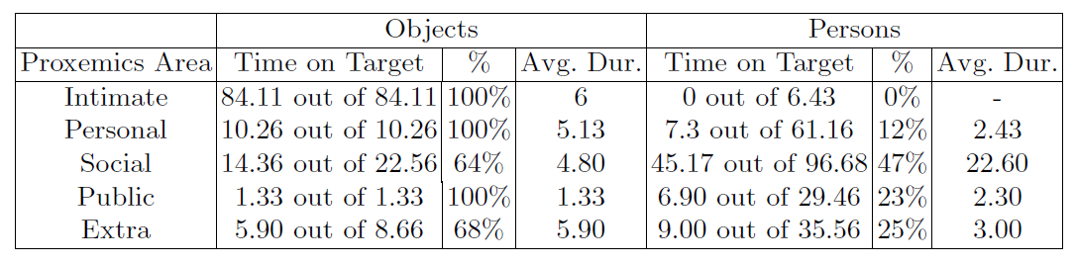

**Chapter writing style:**

**CHAPTER 1**

**Introduction**

**Some Other Instructions:**

**Thesis/Project Size**: 30-45 page limit for Bachelor program

**Page Setup**: Left- 1.25"

Right-1.25"

Top: 1.0-1.25"

Bottom-1.0-1.25"

Orientation- Portrait

**Paragraph Line Spacing**: 1.5

**Column:** Single column

**Font**: Time New Roman

**Header**: Bold, Capital letter, Alignment-Center, Font-14

**Inner Text**: Font-12, Plain text

**Text Alignment:** Justify  
**Figure caption**: Font-12, Bottom, Center  
**Table caption**: Font-12, Top, Left

**Figure numbers for Appendix**: It should be mentioned according to Appendix number such as Figure A1, Figure B2 and so on.

**Reference**: Font-10

[1] *Author, "Paper Title", Conference/Journal, Volume, page number, Month and year*.

[2] *Author, Book Title, Publisher, Volume, page number, Month and year.*

[3] Y. Yorozu, M. Hirano, K. Oka, and Y. Tagawa, “Electron spectroscopy studies on magneto-optical media and plastic substrate interface,” IEEE Transl. J. Magn. Japan, vol. 2, pp. 740–741, August 1987 [Digests 9th Annual Conf. Magnetics Japan, p. 301, 1982].

[4] Learn about Wikipedia, available at << <http://www.wikipedia.org/>>>, last accessed on 06-06-2014 at 12:00pm.